16/10/2020

CMP4271 Professional Practice for Games Development

Task 3 – Skill and Chance

3.0 Introduction

Noughts and Chances is a game based around Noughts and Crosses, but with an element of chance added to the game to make the game more fun and entertaining. It is a game to be played by two people.

3.1 Materials

Pencil, Rubber and Paper to make the game board

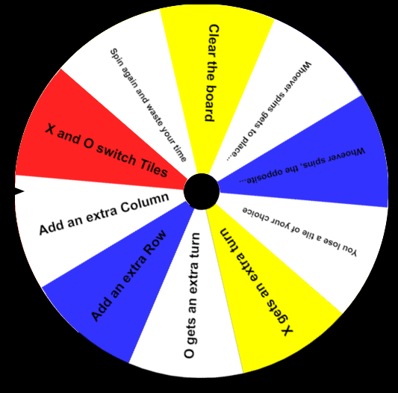

Figure 3.1 A spinning wheel of choices.

3.2 Rules

- A Coin is Flipped (or agreed upon) to decide which player goes first.

- Every round is on a grid that's 3 squares by 3 squares.

- Player 1 is X, player 2 is O. Players take turns putting their marks in empty squares.

- Once each player has had their turn, you must spin the wheel and do what the wheel says.

- The first player to get 3 of their marks in a row (horizontal, vertical or diagonal) is the winner.

- When all squares are full, the game is a tie and the game is played again until there are 3 out of 5 wins.

-The winner is the person who wins the most matches.

3.3 Playtesting

Playtesting identified that the rules: X gets an extra turn and 0 gets an extra turn was too unbalanced. The conclusion was to remove these rules instead and the game ran smoother afterwards.

3.4 Discussion

From creating the game, we learned that the gameplay was too quick and was not our intended effect, it was decided to do a wheel spin after the 2nd player’s turn. After this change, the game rounds were longer which made the gameplay flow smoother. This improved the fun of the game too as rounds would not end as quickly as they had before.

3.5 Reflection

The team I worked with was Zakaria Ahmed, Joshua Baker and Yap Hou Yuen. What I had learned today was that team brainstorming was key because one person could have an idea but not have it thought out, so as a team, we need to constantly think about more ideas as we make the game idea.